Brieanna Williams CSD-325
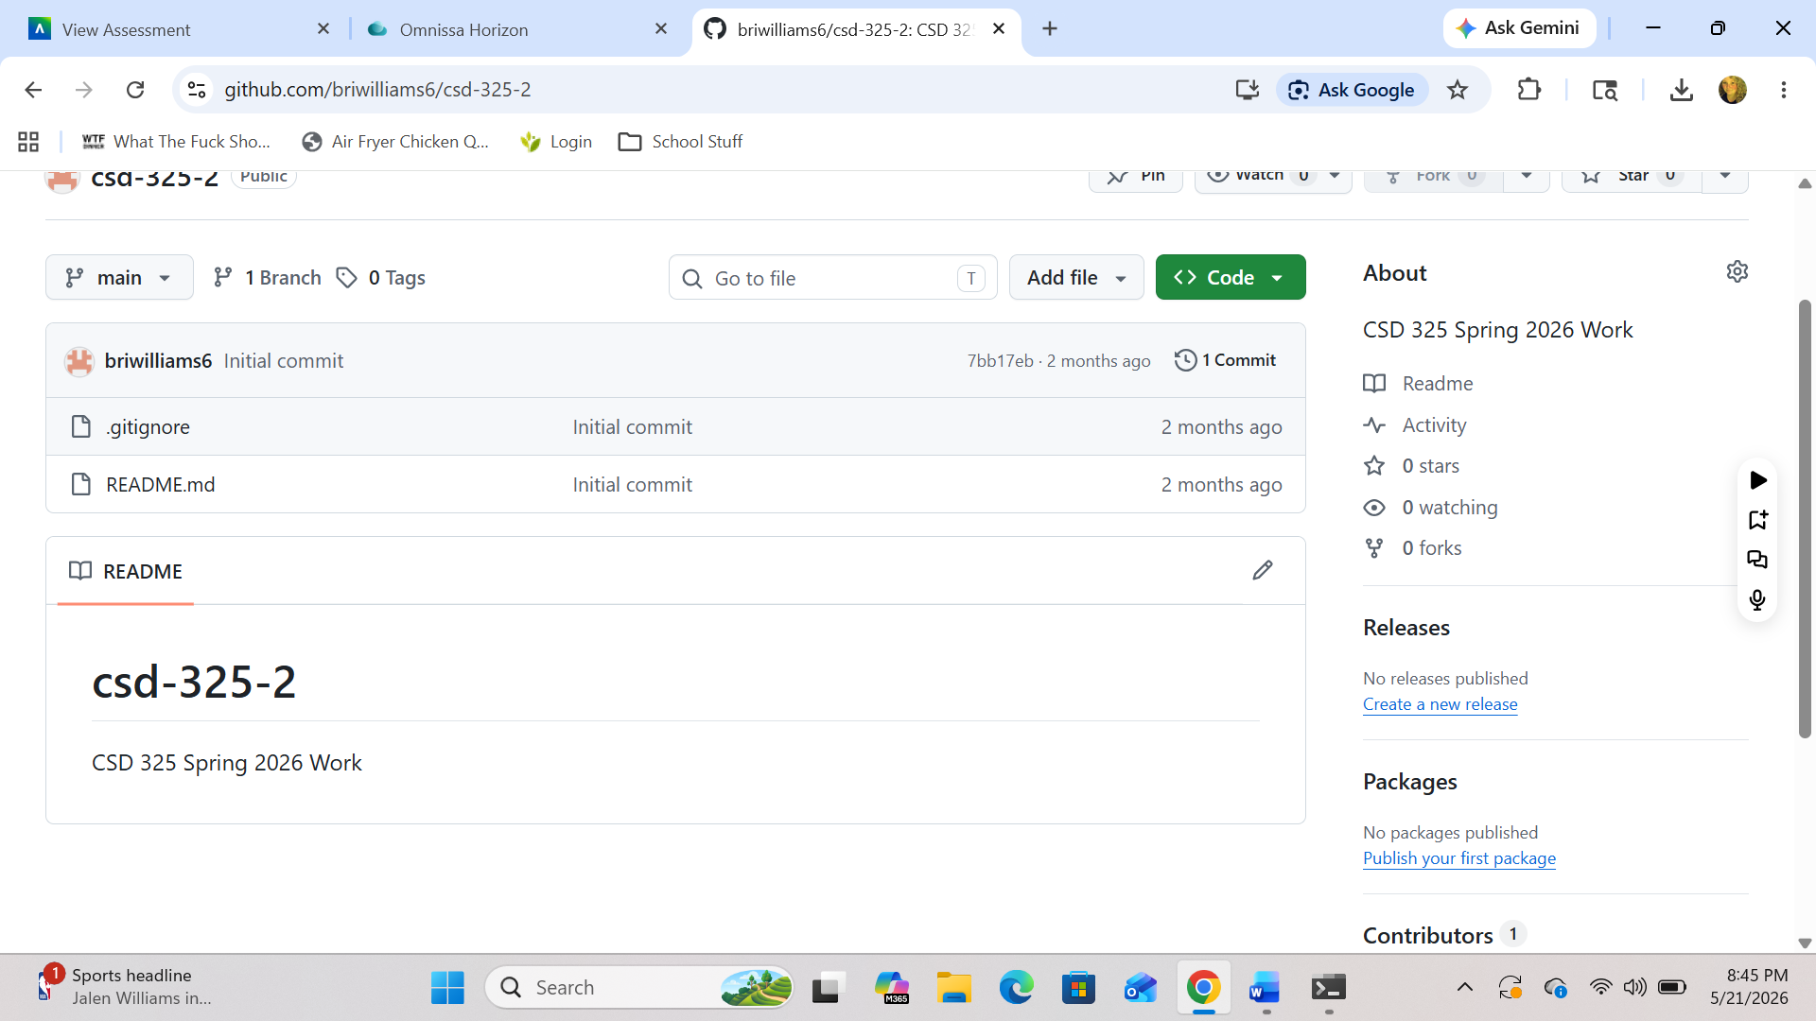
https://github.com/briwilliams6/csd-325-2.git
